1. Source and destinaton Table

Create table src_dest (code varchar(5), detail varchar(20));

1. Airline Table

Create table airline(airline_id int primary key,airline_name varchar(20) not null);

1. Flight Table

Create table flight(flight_id int primary key,airl_id int not null ,src varchar(5) not null,dest varchar(5) not null, ticket_price int default 0, foreign key(airl_id) references airline(airline_id));

1. BOOKING table

Create table booking(booking_id int primary key, booking_dt date not null,flight_id int not null,total_price int not null default 0,src varchar(5) not null,dest varchar(5) not null,bookinguser_name varchar(50) not null,bookinguser_email varchar(30) not null,card_number varchar(20) not null,card_validity_dt varchar(5) not null,dtofjrny date not null, foreign key (flight_id) references flight(flight_id));

1. Passenger table

Create table passengers(booking_id int, pass_name varchar(50), pass_age int,pass_passport_no varchar(20),pass_mobile varchar(20) , foreign key(booking_id) references booking(booking_id));

1. Users table

Create table appusers (userid varchar(10) not null ,password varchar(10) not null,username varchar(50) not null)

1. Alter table appusers add constraint userid_pk primary key (userid);
2. alter table src_dest add constraint code_pk primary key(code);
3. alter table flight add constraint flightid_pk primary key(flight_id);

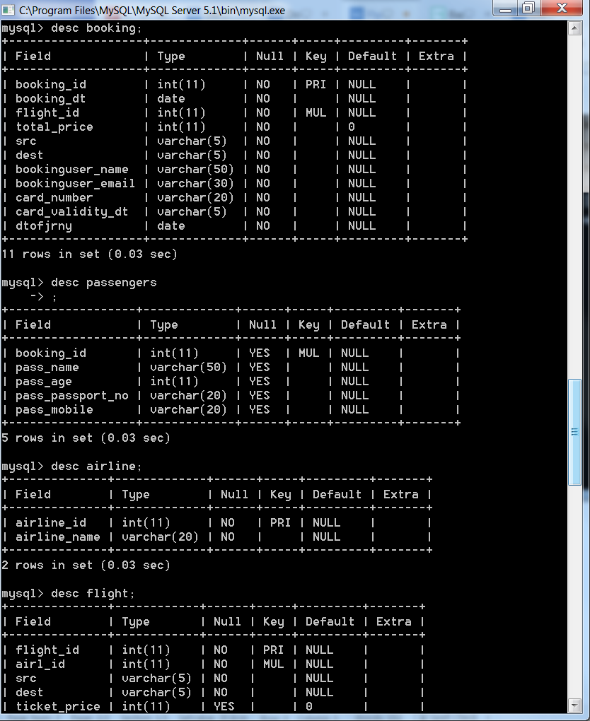

SCREEN 1 ---WELCOME----

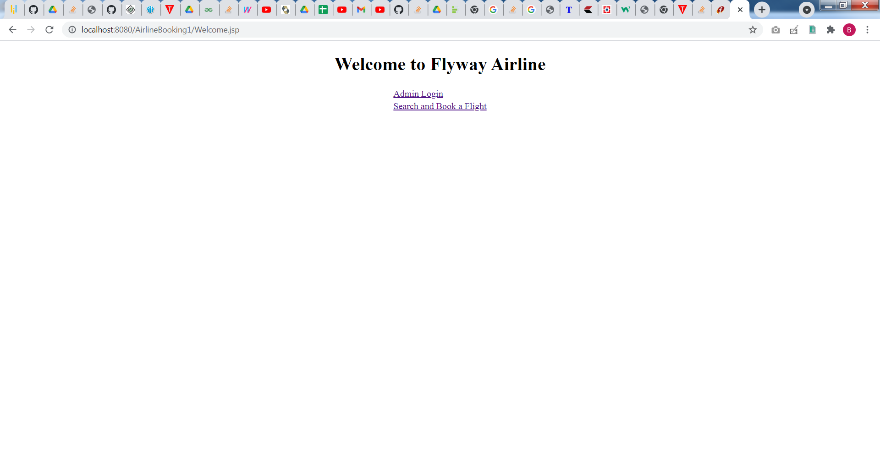

SCREEN-2----ADMIN LOGIN

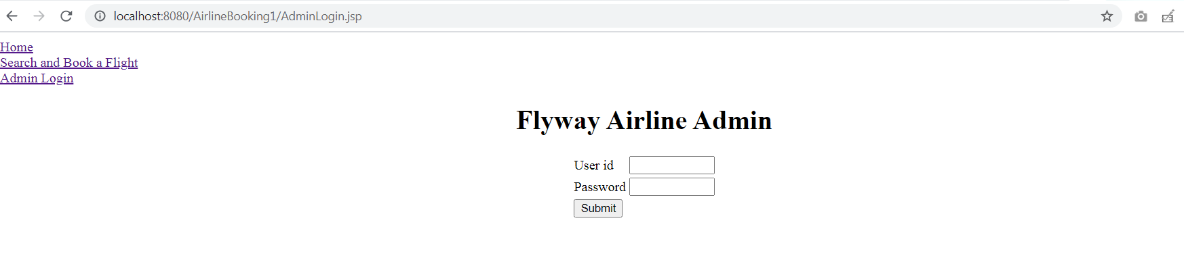

SCREEN 3---ADMIN MENU

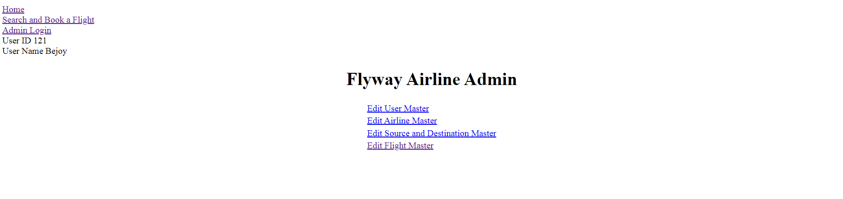

SCREEN 4----EDIT USER MASTER OPTION

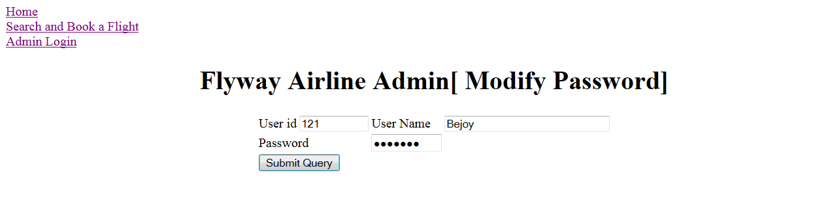

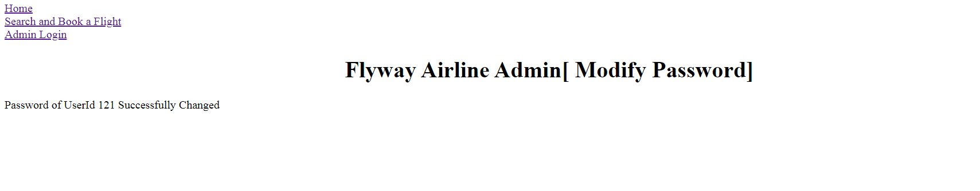

SCREEN 5---EDIT AIRLINE MASTER OPTION

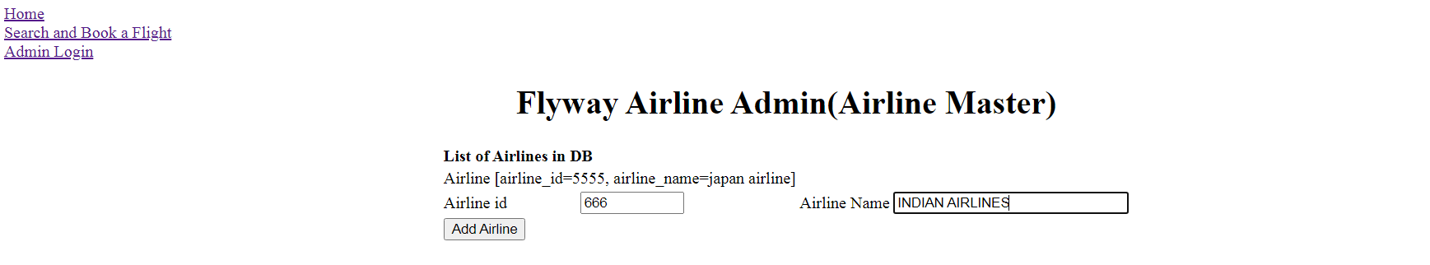

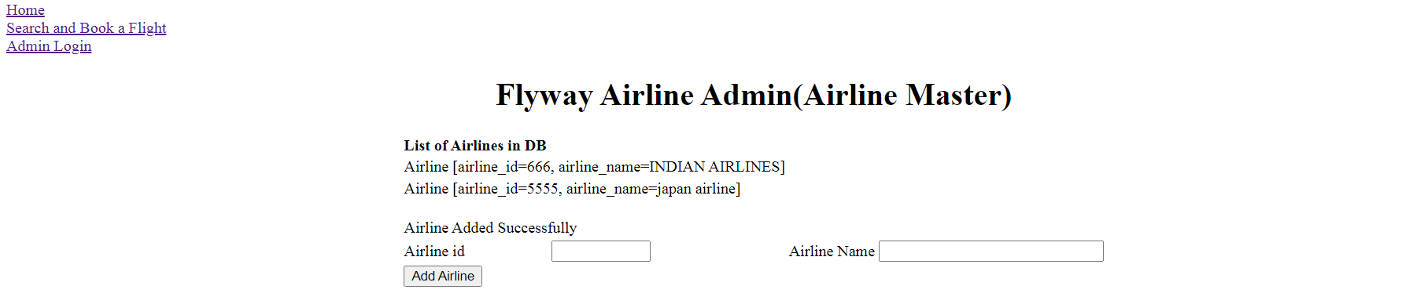

SCREEN 6-- EDIT SOURCE/DESTINATION MASTER OPTION

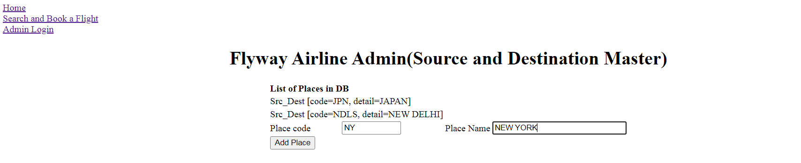

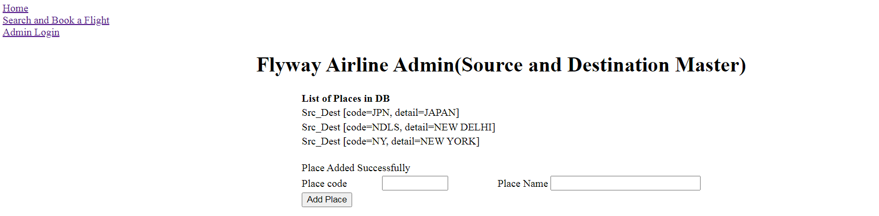

SCREEN 7-- EDIT FLIGHT SCHEDULE MASTER OPTION

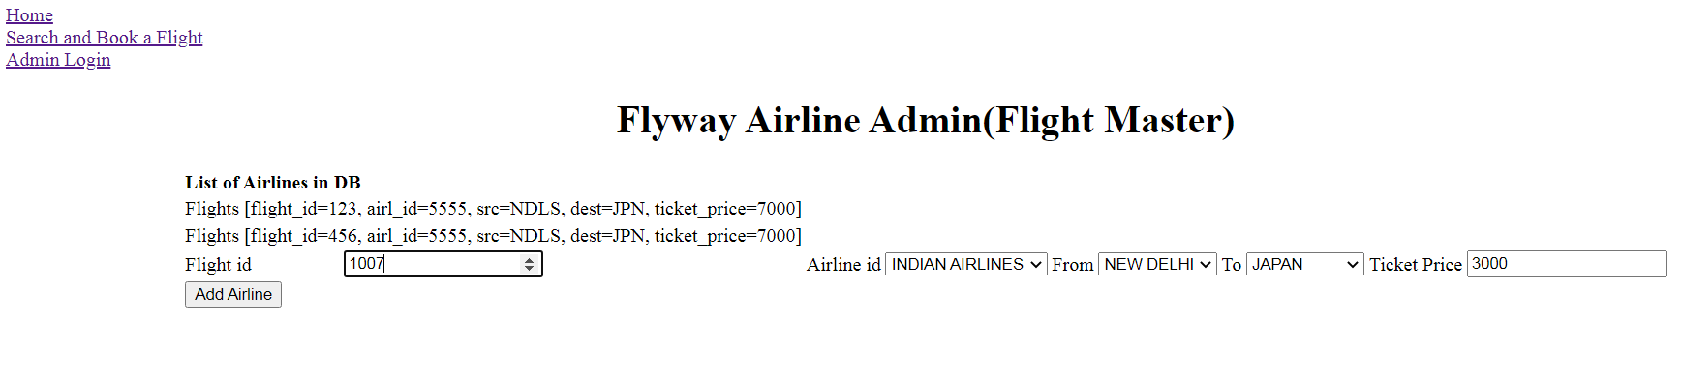

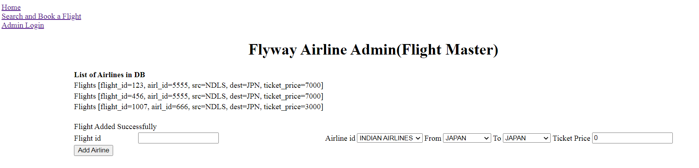

SCREEN 8 ---BOOK FLIGHT1--

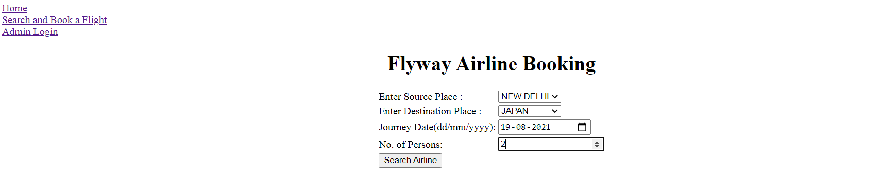

SCREEN 9 ---BOOK FLIGHT2--

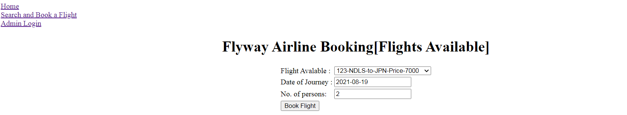

SCREEN 10 ---BOOK FLIGHT3--

